Chemistry Unit 6: Gases
Name _________________________
Period ____ Due Date _________
Let’s Dance!
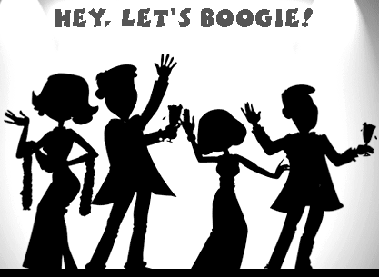
One of the ways we can model matter is through analogies. This enables us to compare certain features of an abstract concept to a situation that is more familiar to you. The following analogy concerns the kinetic molecular theory of gases (KMT).
Imagine a dance club in which a large group of dancers on an enclosed dance floor represents gas molecules inside a container. In each of the following situations the dancers move around on the dance floor but not off of it. Your goal is to explain how each situation relates to behavior of gases according to the postulates of KMT. Consider each of the following characteristics of gases: Volume, pressure, temperature, number of gas particles, and kinetic energy of the gas particles.

- The beat of the music and the number of dancers remain the same, but the size of the dance floor magically increases.
_________________________________________________________________________________
_________________________________________________________________________________
_________________________________________________________________________________
_________________________________________________________________________________

- The size of the dance floor and the beat of the music remain the same, but the song being played is very popular so more dancers move onto the dance floor.
_________________________________________________________________________________
_________________________________________________________________________________
_________________________________________________________________________________
_________________________________________________________________________________

- The size of the dance floor and the number of dancers remain the same, but a slow-dance song is played – and baby, this is a slowwwww jam. I’m talking about Marvin Gaye or Barry White type of slow…
_________________________________________________________________________________
_________________________________________________________________________________
_________________________________________________________________________________
_________________________________________________________________________________

- Suggest another dancing situation and explain how it is analogous to the behavior of gases.
_________________________________________________________________________________
_________________________________________________________________________________
_________________________________________________________________________________
_________________________________________________________________________________
- Which of the variables involving gases does each of the following represent? Explain why.
- number of dancers: _____________________________________________________________
______________________________________________________________________________
- size of the dance floor: __________________________________________________________
______________________________________________________________________________
- beat of the music: _______________________________________________________________
______________________________________________________________________________

- All analogies have limitations. For example, the dancing analogy fails to represent the fact that gas molecules travel at very high velocities on the order of about 6000 km/hr. Dancers move MUCH more slowly, even in the most insane mosh pit.
- Suggest two other characteristics of gases that are not properly represented by the dancing analogy. Explain your choices.
______________________________________________________________________________
______________________________________________________________________________
______________________________________________________________________________
______________________________________________________________________________

- Suggest two aspects of the dancing analogy that may be misleading concerning the behavior of gases.
______________________________________________________________________________
______________________________________________________________________________
______________________________________________________________________________
______________________________________________________________________________

- Write an original analogy that would be useful for modeling gas behavior. And please, no more about dancing – my feet are KILLING me!!!! Identify the features of your analogy that relate to KMT and describe how they relate.
_________________________________________________________________________________
_________________________________________________________________________________
_________________________________________________________________________________
_________________________________________________________________________________
_________________________________________________________________________________
_________________________________________________________________________________
_________________________________________________________________________________
_________________________________________________________________________________

- What are some key limitations in your analogy?
_________________________________________________________________________________
_________________________________________________________________________________
_________________________________________________________________________________
_________________________________________________________________________________

