Unit 5 Thermochemistry Review
Define Essential Vocabulary:
Energy:
Heat:
Temperature:
Heat vs. Temperature:
$Δ$H:
$Δ$E:
$Δ$H vs. $Δ$E:
Endothermic:
Exothermic:
Endothermic vs. Exothermic:
Specific Heat:
Joules (and kJ):
Calories (and Kcal):
Calorimeter:

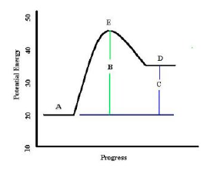
Potential Energy Diagrams:
1.. Does this PE diagram represent and endothermic or
exothermic reaction?

2. What does point A represent?
3. What does point B represent?
4. What does point C represent?
5. What does point D represent?
6. Using the diagram, calculate the ΔH for the reaction shown.

Specific Heat Problems:
- Water has a specific heat capacity of 4.18 J/g°C and iron has a specific heat capacity of 0.45J/g°C. If equal masses of iron and water have equal amounts of energy added, which will heat up more? Why?

- Desert sand is very hot during the day and very cold at night. What does this tell you about the specific heat
capacity of sand? Explain.

9. A 591 g brass candlestick has an initial temperature of 98.0°C. If 21,100J of heat is removed from the
candlestick to lower its temperature to 6.8°C, what is the specific heat capacity of brass?

10. The specific heat of ethanol is 2.46 J/g-oC. Find the heat required to raise the temperature of 193 g of
ethanol from 19 °C to 35 °C.

11. How many kJ of energy are needed to raise the temperature of 165 moles of water from 10.55 °C to 47.32 °C?

Calorimetry
12. A calorimeter contains 100.0 mL of room temperature water (25°C) and a 75.0 g sample of aluminum at
100.0°C is added to it. The final temperature in the calorimeter is 36°C. What is the specific heat capacity of
aluminum?

13. A sample of sodium bicarbonate (NaHCO3) is dissolved in a calorimeter and the following data is
collected. Use the following data to calculate the ΔHsolution of sodium bicarbonate (the heat of dissolution or dissolving of sodium bicarbonate).

Volume of  Water | Mass of Sodium  Bicarbonate Used | Initial Temperature of Water | Final Temperature of Water | Specific Heat of  Water
500.0 mL | 8.956 g | 23.2 C | 3.9 C | 4.184 J/g C

Enthalpy and Stoichiometry:
14. Limestone (CaCO3) decomposes to form caves via the following reaction:
345.6 kJ + CaCO3 + H2SO4 → CaSO4 + CO2 + H2O

Is this reaction endothermic or exothermic?

How many kJ of energy are involved when 50.0 g of limestone is reacted with excess sulfuric acid?

15. Making cement can release a lot of heat through the following reaction
CaO + H2O → Ca(OH)2 + 150 kJ

Is this reaction endothermic or exothermic? If 100.0 g of calcium oxide reacts, how much heat is released?

Use the following constants and figure to answer questions 15 –
All values are regarding water.
ΔH_{fusion}= 334 J/g ΔH_{vaporization} = 2264 J/g C_{ice} = 2.09 J/g°C C_{steam} = 1.84 J/g°C

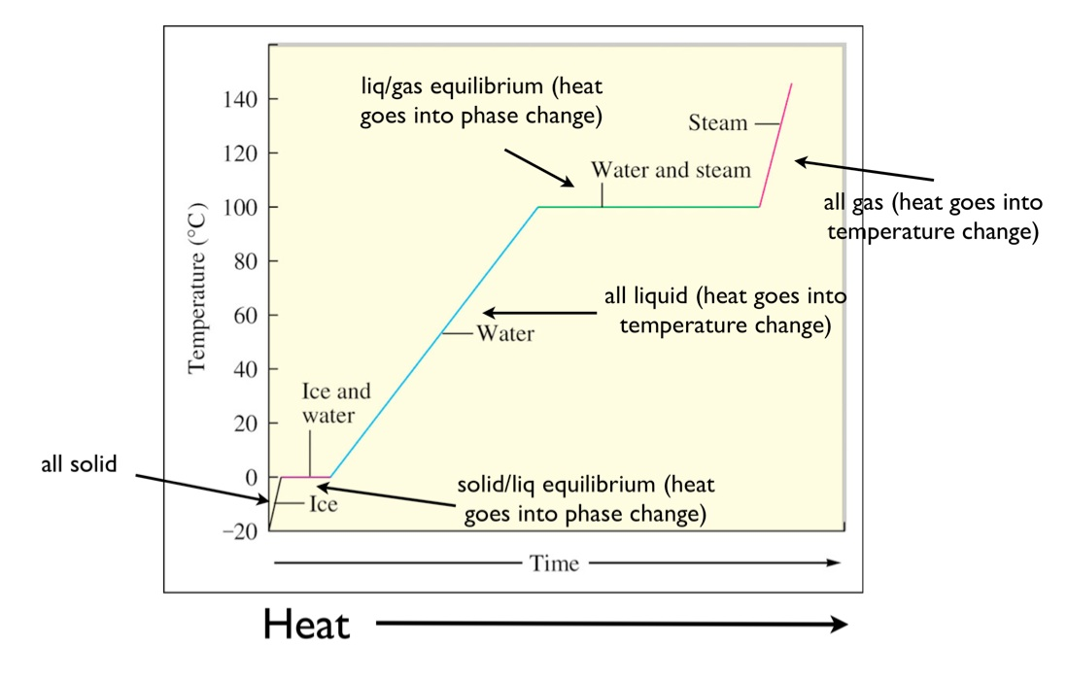
16. How much heat is involved if 192.5 g of water freeze? If 2.70 mols of water freezes?

Is the process endo-or exo-thermic?

17. How much heat is involved if 192.5 g of water melts? If 2.70 mols of water melts?

Is the process endo-or exo-thermic?

18. How much heat is absorbed when 4 g of water evaporates?

19. How much energy is released when 4 g of water condenses?

20. How much energy is absorbed when 100 g of water goes from 40 °C to 23 °C?

21. How much energy is involved when 75 g of water go from 106 °C to 98°C? Is the energy absorbed or released?

22. What amount of energy is put into a container with 2 L of water going from -10 °C to 101 °C?

Additional Resources: Quizzes, lecture, Workbook Practice, Labs and other Worksheets available on my website.

